SmartApp Launch Document
DTR with the payer's own SMART app, through the Payer Gateway and the FHIR API • Oct 30, 2026

1. Purpose and scope
This document explains how DTR (Documentation Templates and Rules) works when the payer has its own form application, a SMART on FHIR app. It lists every call in the order it happens, who makes it, what is sent and what comes back.
When this flow is used: the payer row has DTR_MODE = SmartApp (table PA_PAYER), and the payer's CRD answer contains a card with a link of type smart. For payers with DTR_MODE = Forms, the EHR uses the gateway forms instead (POST /dtr/forms, see the DTR Forms API Guide). No SMART app is needed in that case.
What the EHR has to do in this flow: send order-sign, open one link in a browser window, check the saved forms, and send PAS. The EHR does not need any SMART on FHIR capability. The SMART launch is done by the Payer Gateway and the FHIR API.

2. Who takes part
System | Address (local demo) | Role in this flow
Client EHR | The clinician's screen and browser | Signs the order, opens the DTR link, checks the saved forms, sends PAS.
Payer Gateway | http://localhost:5200 ({gateway}) | Calls the payer for CRD, keeps the launch details, starts the SMART launch, lists saved forms, builds PAS.
FHIR API | http://localhost:5100/fhir/r4 ({fhir}, the SMART "iss") | SMART launch server (discovery, authorize, token) and FHIR data server for the app. Stores the filled-in form.
Payer DTR app | Given by the payer, e.g. https://dtr.payer.example/launch | The payer's own web app. Shows the questions, fills what it can from the EHR data, saves the form.
Payer | Payer base URL from PA_PAYER (demo: http://localhost:5080) | Answers CRD (with the app link) and gives the questionnaires.
EHR data API | {ehr}/api/prior-auth-data | Saves and reads the rows the gateway and FHIR API need (PA_DTR_LINK, PA_QUESTIONNAIRE_RESPONSE).

3. The flow at a glance
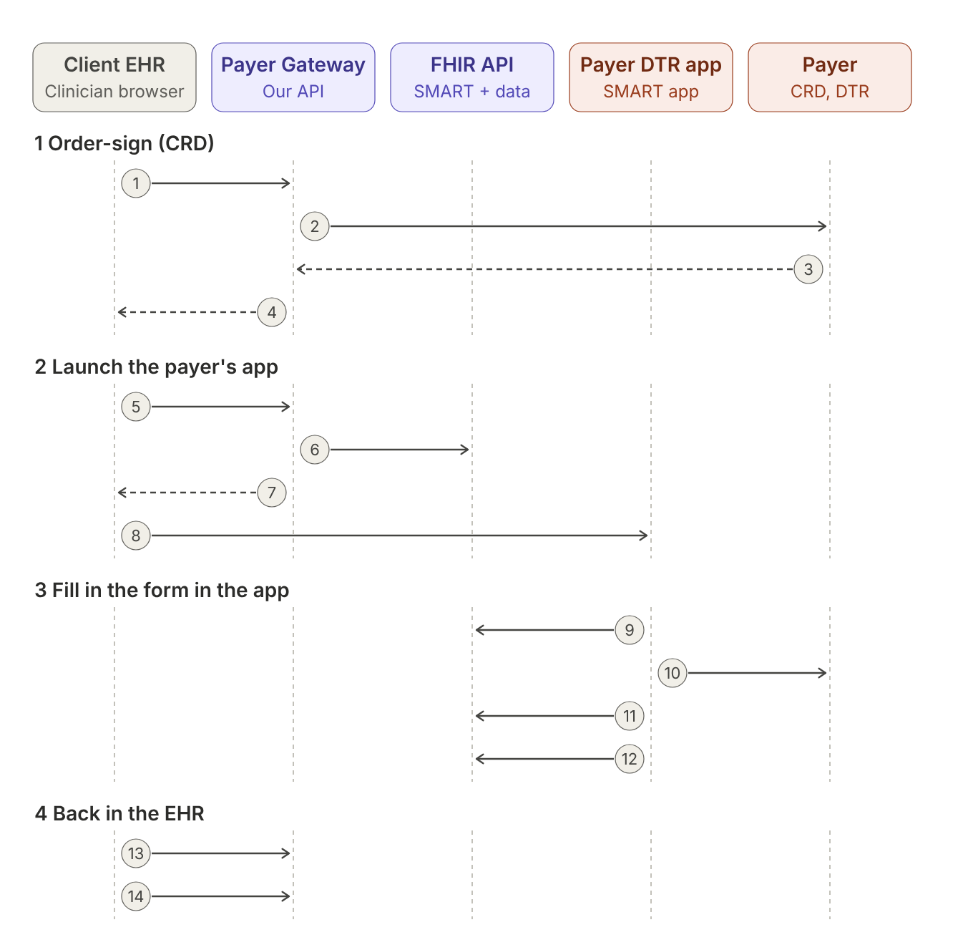
Solid arrow = a request. Dashed arrow = the answer to an earlier request. The numbers are the steps of section 4.
# | From → to | Call | What comes back
1 | EHR → Gateway | POST {gateway}/crd/order-sign | One decision per order (step 4)
2 | Gateway → Payer | CDS Hooks order-sign | Cards and coverage information
3 | Payer → Gateway | (answer of step 2) | A card with a smart link to the payer's app
4 | Gateway → EHR | (answer of step 1) | Decision with link.url = {gateway}/dtr/launch/{linkId}
5 | Browser → Gateway | GET {gateway}/dtr/launch/{linkId} | 302 redirect (step 7)
6 | Gateway → FHIR API | POST /internal/smart-launches | launchId and iss
7 | Gateway → Browser | (answer of step 5) | 302 Location: {app}?iss=...&launch=...
8 | Browser → App | Opens the app URL | The app's page
9 | App → FHIR API | Discovery, authorize, token | Launch context: patient, orders, coverage, appContext
10 | App → Payer | $questionnaire-package | The questionnaires (FHIR Parameters)
11 | App → FHIR API | GET {fhir}/Patient/..., ServiceRequest/..., Coverage/... | FHIR resources to prefill the form
12 | App → FHIR API | POST {fhir}/QuestionnaireResponse | 201 Created, the stored form
13 | EHR → Gateway | GET {gateway}/dtr/saved-forms | The saved forms with their status
14 | EHR → Gateway | POST {gateway}/pas/requests | The prior authorization decision

4. Each step in detail
The examples use the demo data: patient pat-2, order ord-2-home-pd (home dialysis), insurance cov-2, encounter enc-2, clinician prac-3 and the mock payer with insurancePlanId 1001. The ids are examples.

Phase 1: order-sign (CRD)

Step 1: the EHR signs the order
POST {gateway}/crd/order-sign
Called by: the EHR, when the clinician signs the order.
Request
{
"eventId": "evt-20261030-0001",
"insurancePlanId": 1001,
"patientId": "pat-2",
"orderIds": ["ord-2-home-pd"],
"coverageId": "cov-2",
"encounterId": "enc-2",
"userPractitionerId": "prac-3"
}
Inside this one call the gateway makes steps 2 and 3 and saves the link. The answer is step 4.

Steps 2 and 3: the gateway asks the payer
POST {payer}/cds-services/{serviceId}
Called by: the gateway (CDS Hooks order-sign). The EHR does not see this call.
The payer answers with cards. For a payer with its own app, one card has a link of type smart. The link url is the payer's app and appContext tells the app what to load. Part of the payer's answer:
{
"cards": [{
"summary": "Documentation required (clinical): Home peritoneal dialysis",
"indicator": "info",
"links": [{
"label": "Launch documentation (DTR)",
"url": "https://dtr.payer.example/launch",
"type": "smart",
"appContext": "{\"coverage-assertion-id\":\"eeea1400c1b04a0f9b0d2c47e1f3a6d8\",\"questionnaire\":[\"http://example.org/fhir/Questionnaire/home-dialysis-adaptive\"],\"order\":\"ServiceRequest/ord-2-home-pd\",\"coverage\":\"Coverage/cov-2\"}"
}]
}]
}
The gateway does not pass the payer's link to the EHR. It keeps the launch details in table PA_DTR_LINK and gives the EHR its own link instead:
PUT {ehr-data}/dtr-links/{linkId}
Called by: the gateway (EHR data API). Expected answer: 204 No Content.
{
"linkId": "3a3df604a18c4d479f4ed4f05b9a1896",
"insurancePlanId": 1001,
"patientId": "pat-2",
"encounterId": "enc-2",
"userPractitionerId": "prac-3",
"fhirContextJson": "[\"ServiceRequest/ord-2-home-pd\",\"Coverage/cov-2\"]",
"appContext": "{\"coverage-assertion-id\":\"eeea1400c1b04a0f9b0d2c47e1f3a6d8\", ...}",
"appUrl": "https://dtr.payer.example/launch",
"expiresAt": "2026-11-02T13:00:00Z"
}
Which app address is kept in appUrl, in this order: DTR_APP_LAUNCH_URL of the payer row, then the gateway setting Workflow.DtrAppUrl, then the URL on the payer's card.

Step 4: what the EHR gets back
Response 200 OK of step 1. One decision per order. For this flow, look at callDtr and at the message whose link.type is smart:
{
"eventId": "evt-20261030-0001",
"insurancePlanId": 1001,
"decisions": [{
"orderId": "ord-2-home-pd",
"insurancePlanId": 1001,
"coverageId": "cov-2",
"covered": "covered",
"priorAuthNeeded": "auth-needed",
"documentationNeeded": "clinical",
"callDtr": true,
"callPas": true,
"questionnaireUrls": ["http://example.org/fhir/Questionnaire/home-dialysis-adaptive"],
"coverageAssertionId": "eeea1400c1b04a0f9b0d2c47e1f3a6d8",
"messages": [{
"severity": "info",
"summary": "Documentation required (clinical): Home peritoneal dialysis",
"link": {
"label": "Launch documentation (DTR)",
"url": "http://localhost:5200/dtr/launch/3a3df604a18c4d479f4ed4f05b9a1896",
"type": "smart",
"opensPayerApp": true
}
}]
}],
"messages": [],
"payerCall": { "insurancePlanId": 1001, "payerName": "MockPayer", "outcome": "ok", "durationMs": 412 }
}
Value | What the EHR does with it
callDtr = true | A form is needed before PAS.
link.opensPayerApp = true | The payer works with its own app: show a button that opens link.url in a browser window (step 5).
link.url | Always a gateway address. It works for 72 hours (Workflow.DtrLinkHours). After that, sign the order again to get a new link.
The decision itself | The gateway does not keep it. The EHR stores the response and uses insurancePlanId, coverageId, callPas later.

Phase 2: launch the payer's app

Step 5: the clinician opens the link
GET {gateway}/dtr/launch/{linkId}
Called by: the clinician's browser, when the clinician clicks the link. No body, no header needed.
The gateway reads the link from PA_DTR_LINK, checks that it has not expired and that the payer is still configured and enabled, and then makes step 6.

Step 6: the gateway creates the SMART launch
POST {fhir-internal}/internal/smart-launches
Called by: the gateway. This address is for the gateway only and must stay on the internal network.
Request
{
"patientId": "pat-2",
"userPractitionerId": "prac-3",
"encounterId": "enc-2",
"fhirContext": ["ServiceRequest/ord-2-home-pd", "Coverage/cov-2"],
"appContext": "{\"coverage-assertion-id\":\"eeea1400c1b04a0f9b0d2c47e1f3a6d8\", ...}"
}
Response 200 OK
{
"launchId": "6-jM9cmaBKMd4rFPAl-hQp_D",
"iss": "http://localhost:5100/fhir/r4",
"expiresAt": "2026-10-30T13:15:40+00:00"
}
The launch must be used within 15 minutes. Error: 400 { "error": "invalid_request", "error_description": "patientId is required." }.

Step 7: the browser is sent to the app
Response of step 5: 302 Found. The browser follows it at once.
HTTP/1.1 302 Found
Location: https://dtr.payer.example/launch?iss=http%3A%2F%2Flocalhost%3A5100%2Ffhir%2Fr4&launch=6-jM9cmaBKMd4rFPAl-hQp_D
When the link cannot be used, the browser gets a short HTML page "Documentation link unavailable" with the reason:
Status | When
404 | Unknown or expired link ("This documentation link has expired. Sign the order again to get a new link."), or the payer is no longer configured or enabled.
422 | No app address is known for the link.
502 / 503 | The FHIR API (502) or the EHR data API (503) could not be reached. These two come as the gateway's JSON error body, not as the HTML page.

Step 8: the app opens
The payer's app now has two values from its URL: iss (the FHIR address to work with) and launch (the launch id). Everything after this is standard SMART App Launch (EHR launch).

Phase 3: the app fills in the form

Step 9a: discovery
GET {fhir}/.well-known/smart-configuration
Called by: the payer's app, with the iss it received.
Response 200 OK
{
"issuer": "http://localhost:5100/fhir/r4",
"authorization_endpoint": "http://localhost:5100/fhir/r4/auth/authorize",
"token_endpoint": "http://localhost:5100/fhir/r4/auth/token",
"grant_types_supported": ["authorization_code"],
"token_endpoint_auth_methods_supported": ["none"],
"code_challenge_methods_supported": ["S256"],
"response_types_supported": ["code"],
"scopes_supported": ["launch", "fhirUser", "patient/*.rs", "user/*.rs", "patient/QuestionnaireResponse.cu", "patient/*.read"],
"capabilities": ["launch-ehr", "authorize-post", "client-public", "context-ehr-patient", "context-ehr-encounter"]
}

Step 9b: authorize
GET {fhir}/auth/authorize
Called by: the payer's app (in the browser). A form post to the same address works the same way.
Request (query string)
response_type=code
&client_id=payer-dtr-app
&redirect_uri=https://dtr.payer.example/callback
&launch=6-jM9cmaBKMd4rFPAl-hQp_D
&scope=launch openid fhirUser patient/*.rs patient/QuestionnaireResponse.cu
&state=af0ifjsldkj
&aud=http://localhost:5100/fhir/r4
Response
HTTP/1.1 302 Found
Location: https://dtr.payer.example/callback?code=Jx3n0Yd2kQ8mVw5ZrT1uLb7c&state=af0ifjsldkj
The code works once and for 2 minutes. An unknown or expired launch also redirects, with error=invalid_request&error_description=unknown or expired launch&state=.... A missing redirect_uri gives 400 { "error": "invalid_request", "error_description": "redirect_uri is required." }.

Step 9c: token and launch context
POST {fhir}/auth/token
Called by: the payer's app. Body as application/x-www-form-urlencoded.
Request
grant_type=authorization_code
&code=Jx3n0Yd2kQ8mVw5ZrT1uLb7c
&redirect_uri=https://dtr.payer.example/callback
Response 200 OK
{
"access_token": "p0Qm3s8dYw1cV7r2Kx9TbA4nL6eJ5hGf",
"token_type": "Bearer",
"expires_in": 3600,
"scope": "launch openid fhirUser patient/*.rs patient/QuestionnaireResponse.cu",
"patient": "pat-2",
"encounter": "enc-2",
"fhirUser": "Practitioner/prac-3",
"fhirContext": [
{ "reference": "ServiceRequest/ord-2-home-pd" },
{ "reference": "Coverage/cov-2" }
],
"appContext": "{\"coverage-assertion-id\":\"eeea1400c1b04a0f9b0d2c47e1f3a6d8\",\"questionnaire\":[\"http://example.org/fhir/Questionnaire/home-dialysis-adaptive\"], ...}",
"need_patient_banner": false
}
This is the most important answer for the app: patient, fhirContext (the order and the insurance) and appContext (which questionnaire and the payer's coverage-assertion id) tell it what to show. Errors: 400 unsupported_grant_type (grant type is not authorization_code) and 400 invalid_grant ("Unknown, used or expired code.").

Step 10: the app gets the questionnaires
Usually the app calls its own payer directly. That call is between the payer's app and the payer and does not go through our systems. When the app only knows the gateway, it can use the gateway, which passes the call to the payer unchanged:
POST {gateway}/dtr/{insurancePlanId}/Questionnaire/$questionnaire-package
Called by: the payer's app (optional). Body: FHIR Parameters.
{
"resourceType": "Parameters",
"parameter": [
{ "name": "coverage", "resource": { "resourceType": "Coverage", "id": "cov-2", ... } },
{ "name": "order", "resource": { "resourceType": "ServiceRequest", "id": "ord-2-home-pd", ... } },
{ "name": "questionnaire", "valueCanonical": "http://example.org/fhir/Questionnaire/home-dialysis-adaptive" },
{ "name": "context", "valueString": "eeea1400c1b04a0f9b0d2c47e1f3a6d8" }
]
}
Response: the payer's own answer, with the payer's own status code, as application/fhir+json. On success it is a FHIR Parameters with a PackageBundle (the Questionnaire and its CQL Libraries). Gateway errors: 404 (no payer for this insurancePlanId), 502 (payer not reachable), 504 (payer did not answer in time).
Adaptive forms: the app sends the answers so far to POST {gateway}/dtr/{insurancePlanId}/Questionnaire/$next-question (or to its payer directly) and gets the next questions back, passed through the same way.

Step 11: the app reads the EHR data to prefill
GET {fhir}/Patient/pat-2, {fhir}/ServiceRequest/ord-2-home-pd, {fhir}/Coverage/cov-2 ...
Called by: the payer's app, with the access token as Bearer.
Response 200 OK: plain FHIR R4 resources (application/fhir+json), built by the FHIR API from the EHR REST APIs. The app may also search Observation, Condition, Procedure and DocumentReference of the patient to answer questions from its CQL. A missing resource gives 404 with a FHIR OperationOutcome.

Step 12: the app saves the form
POST {fhir}/QuestionnaireResponse
Called by: the payer's app, when the clinician saves or completes the form. PUT {fhir}/QuestionnaireResponse/{id} works too.
Request
{
"resourceType": "QuestionnaireResponse",
"questionnaire": "http://example.org/fhir/Questionnaire/home-dialysis-adaptive",
"status": "completed",
"subject": { "reference": "Patient/pat-2" },
"authored": "2026-10-30T13:20:05Z",
"author": { "reference": "Practitioner/prac-3" },
"extension": [
{ "url": "http://hl7.org/fhir/us/davinci-dtr/StructureDefinition/qr-context", "valueReference": { "reference": "ServiceRequest/ord-2-home-pd" } },
{ "url": "http://hl7.org/fhir/us/davinci-dtr/StructureDefinition/qr-context", "valueReference": { "reference": "Coverage/cov-2" } }
],
"item": [ { "linkId": "training-completed", "answer": [ { "valueBoolean": true } ] } ]
}
Response 201 Created: the form as stored, with the new id, and the header Location: {fhir}/QuestionnaireResponse/{id}. The FHIR API stores it in the EHR database with PUT {ehr-data}/questionnaire-responses/{id} (table PA_QUESTIONNAIRE_RESPONSE). Errors: 400 (not a QuestionnaireResponse, or subject is not a patient) and 502 (the EHR data API failed), both as a FHIR OperationOutcome.
The qr-context extensions matter: the gateway uses them to know which order the form belongs to (steps 13 and 14).

Phase 4: back in the EHR

Step 13: the EHR checks the saved forms
GET {gateway}/dtr/saved-forms?patientId=pat-2&orderId=ord-2-home-pd
Called by: the EHR, when the app window closes or when the clinician returns to the order.
Response 200 OK
[
{
"questionnaireResponseId": "qr-8c1d2e",
"questionnaire": "http://example.org/fhir/Questionnaire/home-dialysis-adaptive",
"status": "completed",
"authored": "2026-10-30T13:20:05Z",
"orderId": "ord-2-home-pd"
}
]
Newest first, an empty list when there is none. DTR is finished for the order when a form has status completed or amended. Errors: 400 (patientId missing), 502 (the FHIR API failed).

Step 14: the EHR sends the prior authorization
POST {gateway}/pas/requests
Called by: the EHR, when the decision of step 4 had callPas = true.
Nothing extra is needed for the form: the gateway attaches every completed or amended form of the same orders automatically. The request and the response are described in the PAS API Guide.

5. Time limits
Item | Valid for | After that
Gateway link /dtr/launch/{linkId} | 72 hours | Sign the order again (step 1) for a new link. Setting Workflow.DtrLinkHours.
SMART launch (launchId) | 15 minutes | Open the gateway link again: it creates a new launch.
Authorization code | 2 minutes, one use | The app starts authorize again.
Access token | expires_in 3600 seconds | Reported to the app; not checked yet (section 8).

6. Settings that affect this flow
Setting | Effect
PA_PAYER.DTR_MODE = SmartApp | Turns this flow on for the payer: link.opensPayerApp = true.
PA_PAYER.DTR_APP_LAUNCH_URL | Fixed app address for the payer. Empty = the URL on the payer's card.
Workflow.DtrAppUrl (gateway) | One app address for all payers (used when the payer row has none).
Workflow.GatewayPublicBaseUrl (gateway) | Start of the link given to the EHR. The clinician's browser must reach it.
Workflow.DtrLinkHours (gateway) | How long the link works (default 72).
FhirServer.PublicBaseUrl (FHIR API) | The iss sent to the app. The payer's app must be able to reach it.

7. What each side must provide

The client EHR
- Send insurancePlanId, coverageId and userPractitionerId in order-sign (step 1).
- Open link.url in a browser window: the default browser or an embedded browser control. No SMART on FHIR support is needed in the EHR.
- Check GET /dtr/saved-forms and then send PAS.

The payer
- A SMART app that supports the EHR launch (iss and launch in the URL) and reads fhirContext and appContext from the token answer.
- The app address, on its CRD card or for DTR_APP_LAUNCH_URL.
- The app saves its QuestionnaireResponse at iss, with the DTR qr-context extensions for the order and the coverage.
- Later, when security is added: its client id and redirect URLs.

Our side (gateway and FHIR API)
- Both addresses (GatewayPublicBaseUrl for the browser, FhirServer.PublicBaseUrl for the payer's app) reachable from where they are used.
- /internal/smart-launches reachable from the gateway only.

8. Security today
No authentication is built into this code; it is added outside it. Today:
- authorize does not check the app (client_id), its redirect URL, PKCE or the scopes;
- the access_token is a random value that no FHIR endpoint checks.
Before a real payer app is used, the security layer has to register each payer app with its redirect URLs, require PKCE, and issue signed tokens that the FHIR endpoints check (including that a patient token can read only that patient). This can be done in the FHIR API itself or with an identity server such as Keycloak with a SMART extension; the gateway and the EHR do not change.

9. In the local demo
The mock payer's card points to https://dtr.example.org/launch, which is not a real app. Steps 1 to 8 can be shown: the link opens and the browser is sent to that address with iss and launch. Steps 9 to 12 work once a payer provides its app. Until then, use the payer in Forms mode (DTR Forms API Guide).

10. Document history
Version | Date | Change
1.0 | Oct 30, 2026 | First version: the DTR flow with the payer's own SMART app, every call with its request and response.

